18.25: a)

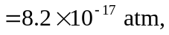

about 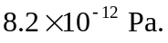 This is much lower, by a factor of a thousand, than the pressures considered in Exercise 18.24. b) Variations in pressure of this size are not likely to affect the motion of a starship.

